**TASK PERFORMANCE**

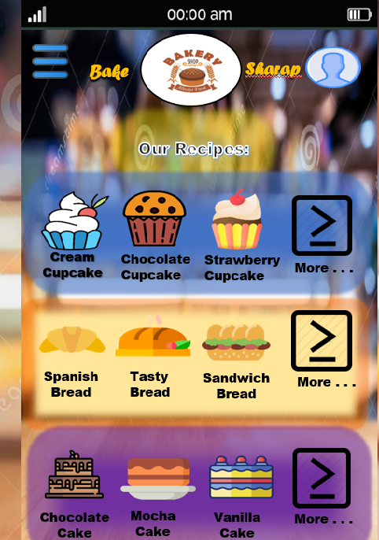

On this page, I applied the **Reduce memory load** HCI principles. To keep the number of menu items and to easier order or buy our recipes. Through this principles, people directly buy their want and no more other options that makes them confused. This principle also can help us especially old people that’s have an slow memory because of their age.

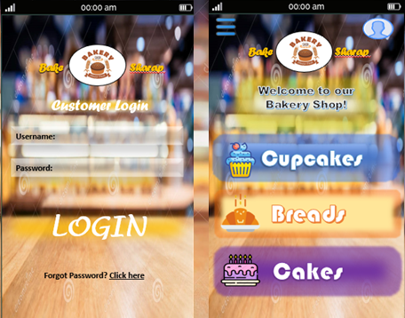****

I applied the **Strive for consistency** on these pages, a way to relieve long term memory load of the user. I’ll make my design consistency for people who confused with the inconsistent design. From this design, it help us to be familiar of the order system and menu items that we easier to do. So even old or young people, can easier to buy or order our recipes because of the consistent design that make us familiar.